Associate Editor

Comments to the Author:

1. As authors mentioned, this topic has been investigated in previous study (Ref 31). Authors need to clearly demonstrate the novelty of this study compared with the previous study in introduction.

**Response:** We agree and have added text to the updated manuscript’s Introduction section. On page 3 of the revision, we write: “Few studies have estimated the number and timing of BP measurements required to obtain an estimate of mean BP during sleep similar to that obtained by a full night of ABPM (i.e., using ABPM throughout an entire night). Others have previously studied the validity of using a fixed number of BP measurements, sampled randomly during wakefulness or sleep, to determine how many measurements were needed for reliable estimation of mean BP in the research setting. In the current study, we investigate the specific timing, as well as the number, of measurements needed for reliable estimation of mean BP during sleep. Using data from participants in the Jackson Heart Study (JHS) and the Coronary Artery Risk Development in Young Adults (CARDIA) study, we evaluated 74 variations on the number and timing of BP measurements during sleep to assess whether a limited number of BP measurements, taken at specific times, could provide an accurate estimate of mean BP from a full night of ABPM.”

2. Please revise the reference 3 into the latest version (Hypertens Res 2019; 42: 1235-1481).

**Response:** Thank you. The reference has been corrected.

Reviewer: 1

This paper investigated the optimal number and timing of the BP measurements during sleep which may have high agreement with the diagnosis of nocturnal hypertension based on a full night of ABPM. The results showed that measuring BP 3 or 4 times during sleep with at least 1 hour between measurements resulted in high agreement with a full night of ABPM. The method for evaluating the different sampling variations was systematic and clear. I have only one minor comment.

Minor comment:

BP sampling at 1, 2, 4, and 5 hours after falling asleep had not only the highest Kappa statistic for nocturnal hypertension but also the lowest mean absolute error (3.11) for mean systolic BP during sleep. It is an interesting finding and it should be discussed more. I do think that the agreement in the absolute BP value is of interest to readers of this journal.

**Response:** We agree with the reviewer and have made some modifications in the revised manuscript’s Results and Discussion section to draw more attention to this finding. In the Results section on page 9, we have written “In addition to obtaining the highest Kappa statistic in the pooled Cohort, sampling BP at 1, 2, 4 and 5 hours after falling asleep also provided the lowest mean absolute error for asleep SBP relative to a full night of ABPM (3.11 mm Hg, 95% CI 2.97, 3.26).” We have also modified the first sentence of our Discussion section (see page 11): “In the current study, the highest Kappa statistic assessing agreement with nocturnal hypertension based on a full ABPM assessment, and lowest mean absolute error for estimating mean SBP during sleep resulted from sampling BP at 1, 2, 4, and 5 hours after falling asleep.”

Reviewer: 2

The aim of this observation study was to assess whether a limited number of blood pressure (BP) measurements could provide an accurate estimate of mean BP from a full night of ambulatory BP monitoring (ABPM) in the Jackson Heart Study and the Coronary Artery Risk Development in Young Adults (CARDIA) study cohort (n=1,079, mean age 57.1±8.6 years, 32.0% male, 81.0% black). This study assessed the Kappa statistics of nocturnal hypertension among each BP measurement timing. This study demonstrated that measurement BP at 3 times (2, 3, and 4 hours after falling asleep) or 4 times (1, 2, 4 and 5 hours after falling asleep) during sleep would show high agreement with the status of nocturnal hypertension assessed by a full night of ABPM.

Comments

・Although this study estimated the accuracy of nocturnal hypertension using different timing of nocturnal BP measured by ABPM for applying for the estimation of nocturnal hypertension using home BP monitoring (HBPM), I think HBPM and ABPM would be entirely different. Recent study demonstrated that nocturnal hypertension defined by HBPM were significant risk factor for future cardiovascular disease event, on the other hand, that defined by ABPM were not.(Mokwatsi GG, et al. Hypertension. 2020;76:554-561.) How do you think about the differences between HBPM and ABPM? I agree that fewer BP measurements during asleep would reduce discomfort and disrupted asleep. So, the results of this study would have much potential to apply for HBPM.

**Response:** We agree that associations between cardiovascular events and out-of-office BP may differ when nocturnal BP is measured with HBPM rather than ABPM. We conducted the current study to inform future studies that would use an HBPM device specifically designed to automatically take a limited number of BP readings during sleep. In light of the recent results from Mokwatsi et al, we have updated our Discussion section. On page 12-13, we write

“In the Japan Morning Surge Home Blood Pressure (J-HOP) study, BP measured at 2am, 3am, and 4am was associated with LVMI and ACR, independent of clinic BP and home BP during the morning and evening.14 The current study replicates these results by showing that BP measured 2 to 4 times during sleep is associated with LVH and albuminuria in other cohorts. Another analysis of the J-HOP data found that mean BP from a self-measured HBPM device programmed to measure BP at 2am, 3am, and 4am over an average of 8.89 nights was associated with incident CVD events but found no evidence of association between mean BP from a single night of ABPM and CVD. The current study found a mean absolute difference of roughly 4 mm Hg in SBP between a full night of ABPM and measuring BP at 2am, 3am, and 4am. Future studies should identify whether the additional prognostic value of HBPM versus ABPM for incident CVD risk persists when both techniques are repeated over multiple nights.”

・I think the authors should describe clearly that the gold standard for measuring nocturnal BP levels still have been an ABPM.

**Response:** In the updated manuscript, we write “ABPM is widely recognized as the gold standard for measuring BP during sleep”

・The authors had better show the mean BP levels of each measurement timing. I would like to ask the authors why BP measured by 2, 3, and 4 hours or 1, 2, 4 and 5 hours after falling asleep would be important for diagnosing nocturnal hypertension and. In addition, do you think that bedtime-based nocturnal BP measurement (e.g., 2, 3 and 4 hours after falling asleep ) would be more important for diagnosing nocturnal hypertension compared to fixed-time nocturnal BP measurement (e.g., 2:00, 3:00 and 4:00)?

**Response:** We think this is an excellent idea and have included two figures (one for SBP and the other for DBP) in the revised manuscript that investigate mean BP during sleep for the current study. Because the participants who underwent ABPM had measurements occurring on different schedules, we applied linear regression with a cubic spline to estimate a smoothed mean BP curve during the first 8 hours of sleep and the first 8 hours after midnight, separately, to create these figures. The figure showing SBP values is included below.

**Figure:** Estimatedmean systolic blood pressure values over time among participants in the Coronary Artery Risk Development in Young Adults study (top row) and the Jackson Heart Study (bottom row). Mean values are drawn with respect to time since falling asleep (left column) and time since midnight (right column).

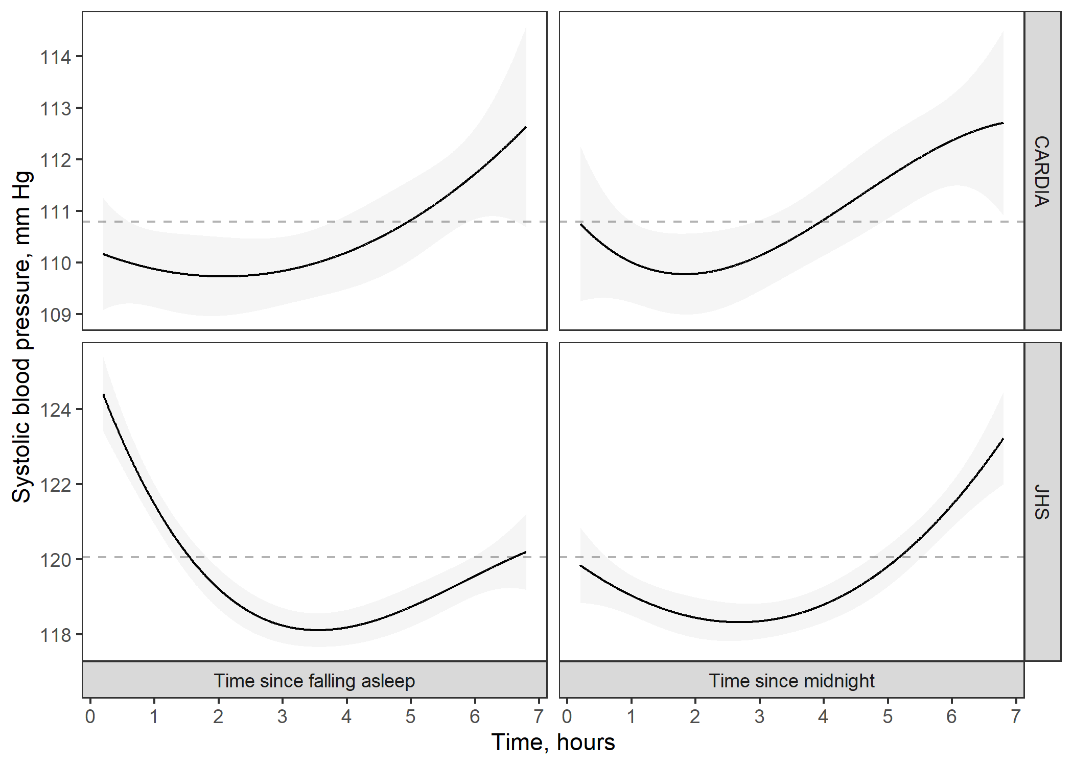

Blood pressure was estimated using linear regression with a natural cubic spline to capture nonlinear patterns in blood pressure over time.

Shaded ribbons around the black lines show 95% confidence limits for the blood pressure estimates.

The grey dashed line shows the mean systolic blood pressure during sleep for participants in the Coronary Artery Risk Development in Young Adults study (top row) and the Jackson Heart Study (bottom row)

If the trajectory of BP was flat during sleep, it would not matter when we sampled BP. However, the trajectory of BP does not appear to be flat in either cohort when assessed using time since falling asleep or time since midnight. Based on this observation, we speculate that BP measured by 2, 3, and 4 hours or 1, 2, 4 and 5 hours after falling asleep would be important for diagnosing nocturnal hypertension because these sampling times tend to coincide with the period of sleep when BP is dipping, rising, or at its minimum point during sleep. Therefore, the mean of BPs at these sampling times may yield estimates of mean BP during sleep that are closest to that of full ABPM because they average over both the diurnal pattern and diurnal fluctuations in BP during sleep, i.e., they capture the U-shaped BP curve that usually occurs during sleep.

We do not have sufficient data in the current study to determine which time definition (i.e., time since midnight versus time since falling asleep) is more important for diagnosing nocturnal hypertension. However, it is clear enough from the patterns of variability in sleep data (i.e., study participants go to sleep at a broad range of times) that using the more flexible approach (time since falling asleep) will be more likely to successfully straddle the U-shaped BP curve that usually occurs during sleep. Hence, we speculate that using time since falling asleep to diagnose nocturnal hypertension using 3 or 4 BP readings will be preferable in future studies. Based on this comment, we have added a brief paragraph to the Discussion section. On page 13, we write

“The current study assessed BP sampling variations that measured time relative to midnight and relative to the onset of sleep. Although both definitions of time are valid, the latter may be more likely to adequately measure BP during sleep in studies where participants go to sleep at a broad range of times. Study participants may also prefer the latter definition as it does not require them to be asleep at specific times. Future studies should investigate reliability of and preference for HBPM devices that are programmed to measure BP at times relative to midnight versus the onset of sleep.”

・As you have described as a study limitation, I think the results of this study could not apply for the elderly, who generally wake up early and did not sleep over 5 hours.

**Response:** Thank you for acknowledging this. We deliberated over how to design the current study and ultimately decided to favor a strict set of inclusion criteria to ensure the results would not be confounded by abnormal sleeping patterns. In light of your comment, we have revised our limitation. On page 13, we write “Results from the current study may not generalize to settings where participants sleep for <5 hours or miss planned BP measurements, e.g. older adults who typically wake up early and do not sleep for 5 consecutive hours.”

・I think the results of this study would statistical, not practical. How do you apply the results of this study for the management of hypertension?

**Response:** We agree that the current study has findings that do not have immediate practical application. Presently, the current study’s findings are mainly applicable to investigators of BP during sleep. For example, investigators may decide to measure BP at 1, 2, 4, and 5 hours after participants fall asleep in their study so that (1) they are likely to obtain valid estimates of asleep BP that show high agreement with the estimates that would have been obtained if a full night of ambulatory BP monitoring was completed, (2) participants are less likely to experience sleep disturbance, and (3) participants may be more likely to agree to repeat the monitoring of BP during sleep if the procedure causes little or no sleep disturbance. However, the results may have clinical relevance in the future if monitoring nighttime BP becomes standard practice in the clinical management of BP and hypertension. To emphasize the implications of the current study, we added the following sentence to conclude the revised paper (see pages 13-14): “Investigators of BP during sleep may find the current study’s results relevant for designing and implementing future studies that measure BP during sleep, as the use of 3 to 4 BP measurements instead of 16 or more BP measurements could improve study recruitment and increase the likelihood of participants’ agreeing to have their sleep BP assessed multiple times. Results from the current study also suggest that manufacturers of HBPM devices that measure BP at specific times during sleep can implement more flexible options, such as measuring BP at times relative to midnight or the onset of sleep.”